**📘 Technical UI Documentation**

**Project:** Smart School Lab Manager – IoT Lab  
**Focus:** UI Design – Wireframe Documentation  
**Author:** Albert A Allen  
**Date:** May 13, 2025

**1. Overview**

The UI design for the Smart School Lab Manager emphasizes role-based access and IoT device control within a school environment. The interface is clean, minimal, and user-friendly to suit both technical and non-technical users, such as ICT teachers, lab technicians, and students.

**🧱 2. Screen Breakdown**

**1. Login Page**

**Purpose:**  
Provides access to the system for users based on their role (Teacher or Student).

**Key Elements:**

| **Component** | **Type** | **Description** |
| --- | --- | --- |
| Logo / App Title | Header | Displays branding or system name |
| Username Field | Text Input | For user login credentials |
| Password Field | Password | Hidden input for security |
| Role Selector | Dropdown | Choose between Teacher and Student |
| Login Button | Button | Submits credentials |
| Forgot Password | Text Link | Optional feature for password recovery |

**Navigation Flow:**  
After successful login → Redirect to appropriate dashboard (Teacher or Student).

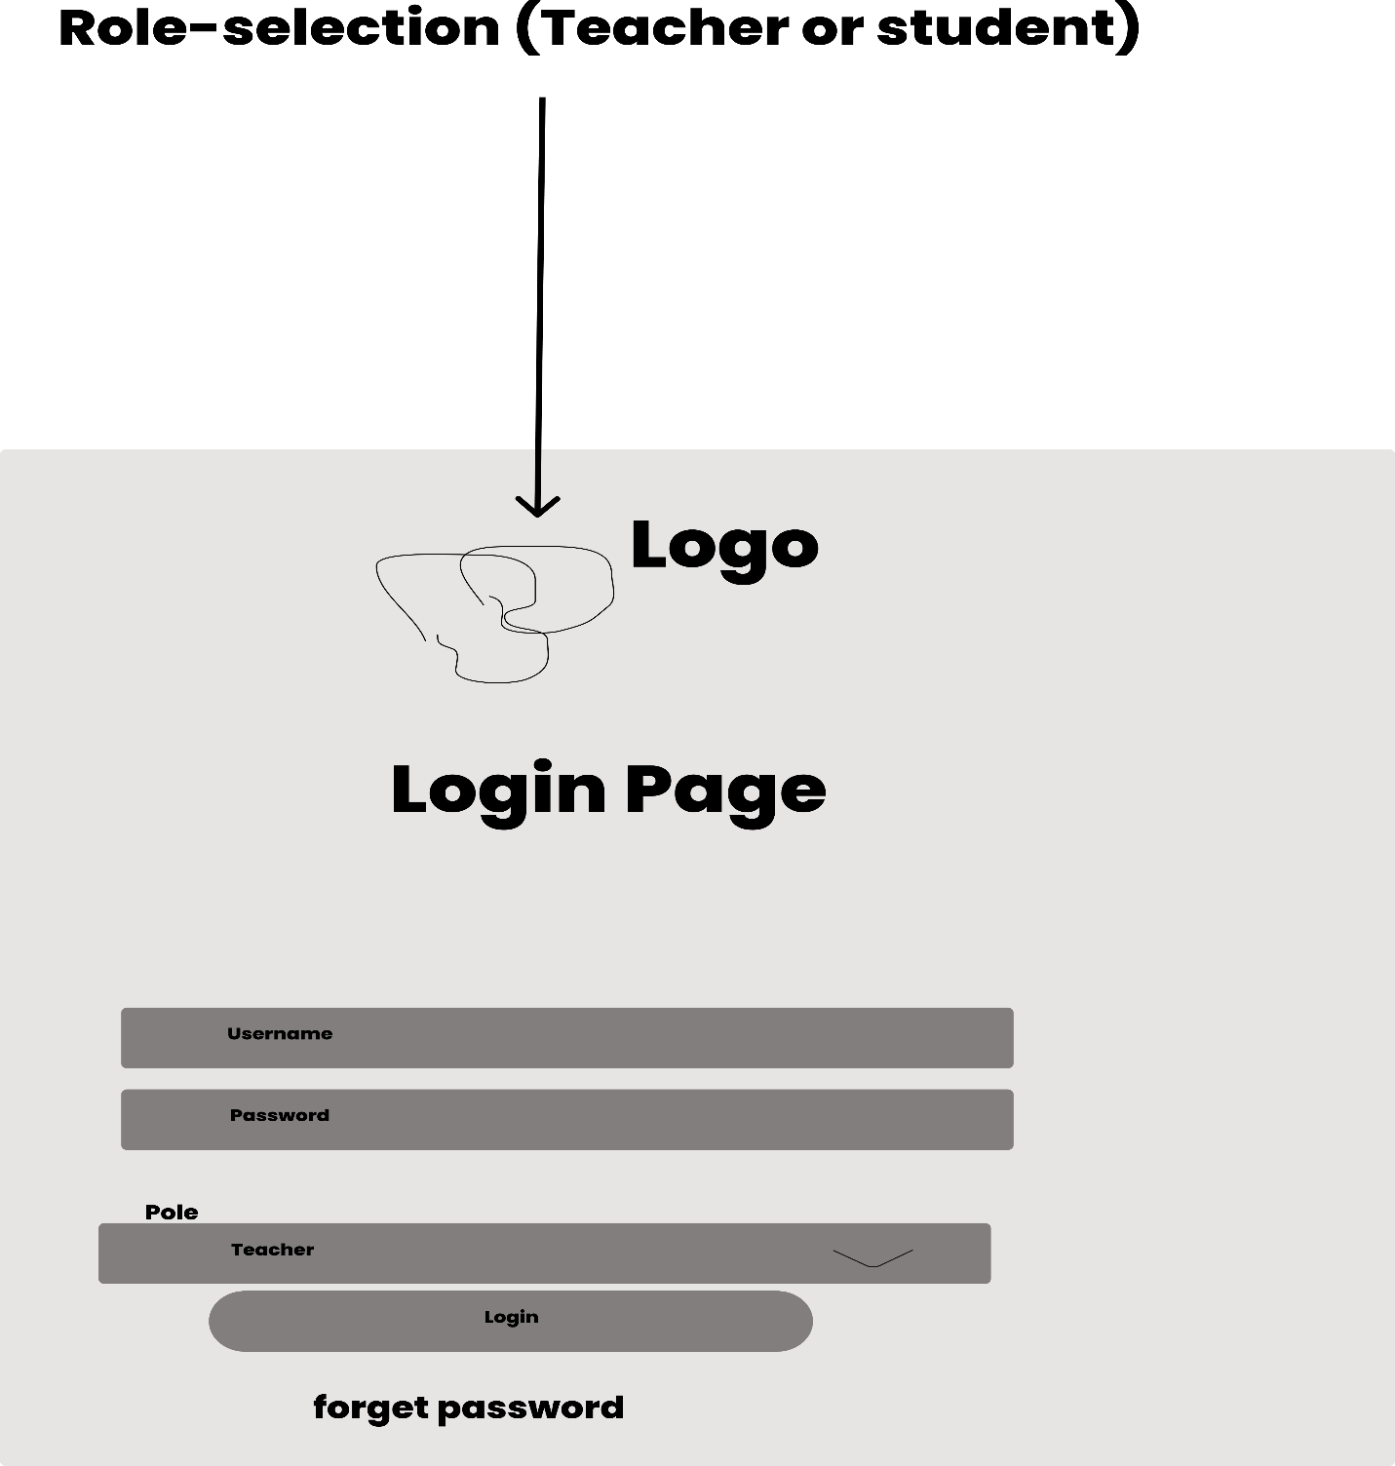

**📋 2. Teacher Dashboard**

**Purpose:**  
Allows the teacher to control, monitor, and automate IoT devices in the lab.

**Key Elements:**

| **Component** | **Type** | **Description** |
| --- | --- | --- |
| Welcome Message | Text | Personalized greeting |
| Device List | List/Grid | Shows each device with name & status |
| Device Toggle | Switch | On/Off controls for each device |
| “Turn All Off” Btn | Button | Emergency shut-down for all devices |
| Alerts/Notifs Area | Panel | Shows recent notifications or warnings |
| Top Navigation Bar | Menu | Links to Logs, Settings, Dashboard |

**Interaction Flow:**

* Toggle individual devices
* View system alerts
* Navigate to logs or settings

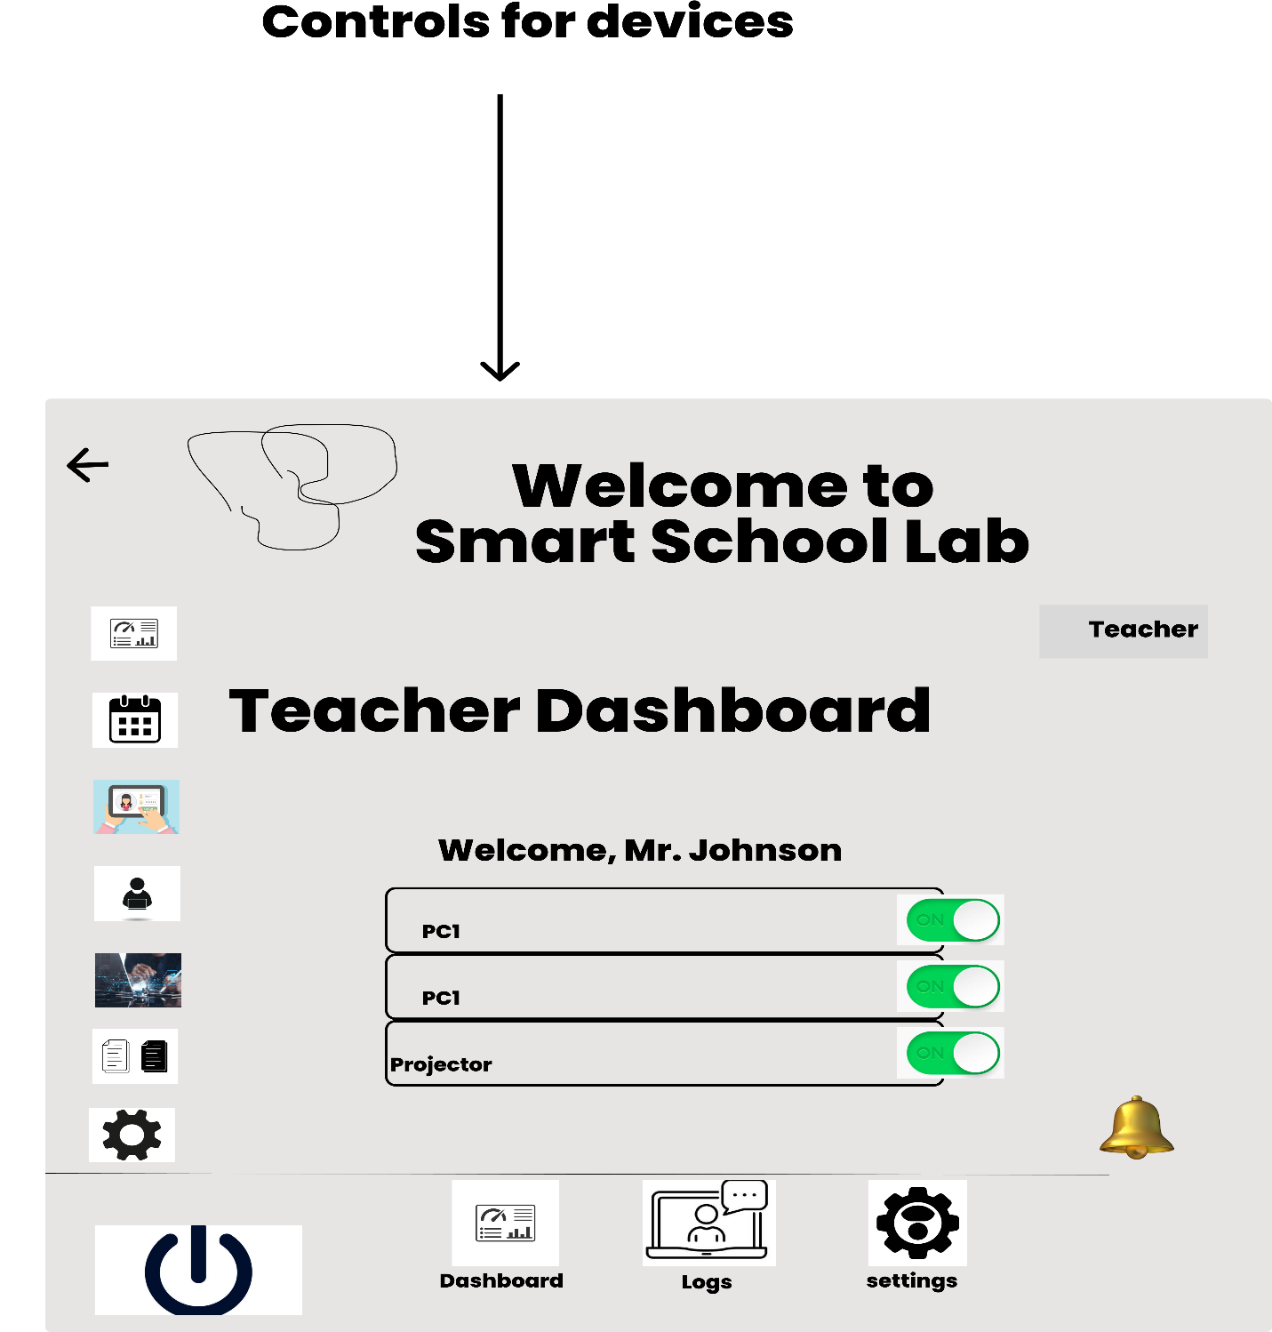**👨‍🎓 3. Student Dashboard**

**Purpose:**  
Allows students to view permitted devices and their status.

**Key Elements:**

| **Component** | **Type** | **Description** |
| --- | --- | --- |
| Accessible Devices | List | Devices student has permission to view/use |
| Status Indicators | Labels | ON/OFF indicators without control access |
| Request Access Btn | Button | Students may request permission to access |
| Info Area | Panel | Shows system rules or recent activity |

**Permissions:**

* Students **cannot control** devices directly
* Read-only access with limited interactions

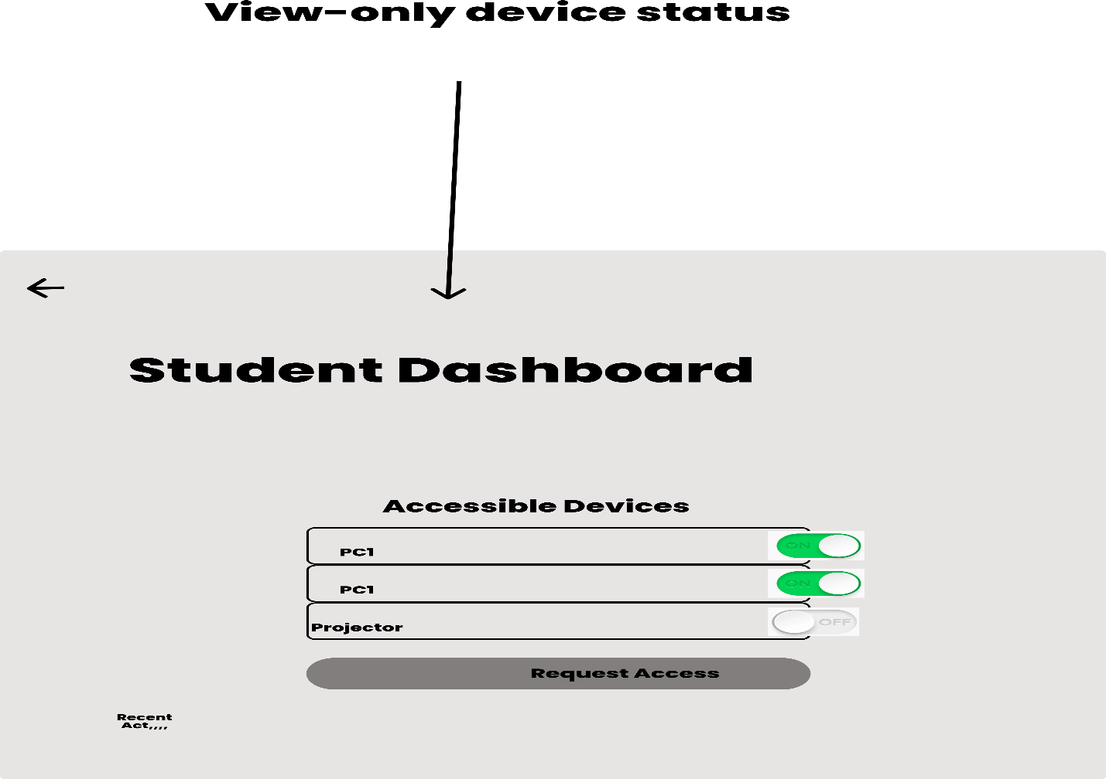

**🔌 4. Device Control Panel**

**Purpose:**  
Provides a detailed view for managing individual devices.

**Key Elements:**

| **Component** | **Type** | **Description** |
| --- | --- | --- |
| Device Name | Header | Title of the selected device |
| Status Indicator | Label | Current power state (ON/OFF) |
| Control Button | Toggle | Power button or switch |
| Usage History Panel | Table/Graph | List of usage records (time, user, status) |
| Schedule Settings | Time Picker | Allows time-based on/off scheduling |

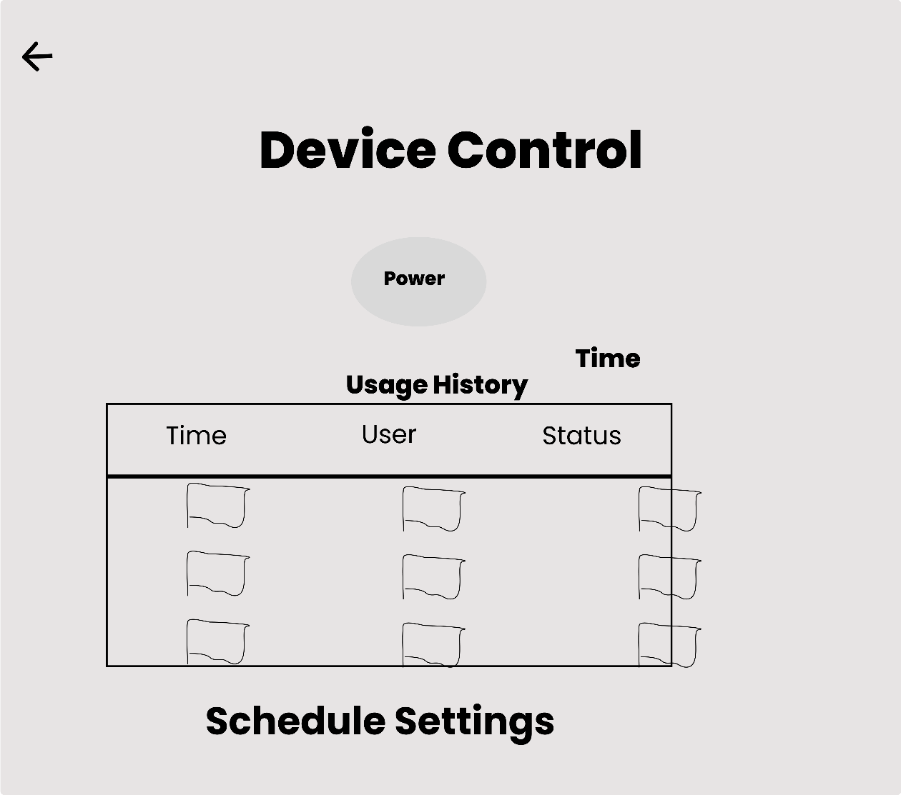

**📊 5. Activity Logs Page**

**Purpose:**  
Tracks system activity for auditing and behavior monitoring.

**Key Elements:**

| **Component** | **Type** | **Description** |
| --- | --- | --- |
| Logs Table | Table | Lists username, action (ON/OFF), timestamp |
| Filters | Dropdowns | Filter by device, user, or date |
| Export Button | Button | Export logs as CSV or PDF (future scope) |

**Use Case:**  
Lab admin or teacher can review student behavior, detect misuse, and optimize usage schedules.

**🧭 3. User Roles and Navigation Flow**

| **Role** | **Initial Screen** | **Access Level** | **Accessible Pages** |
| --- | --- | --- | --- |
| Teacher | Dashboard | Full Control | Dashboard, Logs, Settings |
| Student | Student View | Limited / View | Device List, Request Access |

**🎯 4. Design Goals**

* ✅ **Clarity**: Simple layout with minimal distractions
* ✅ **Role-based UI**: Interfaces change depending on login role
* ✅ **Responsiveness**: Intended for use on laptops and tablets
* ✅ **Scalability**: Future screens can be added (e.g., device scheduling dashboard)

